Discussion Activity (30 minutes):
What does brain development look like in young children?

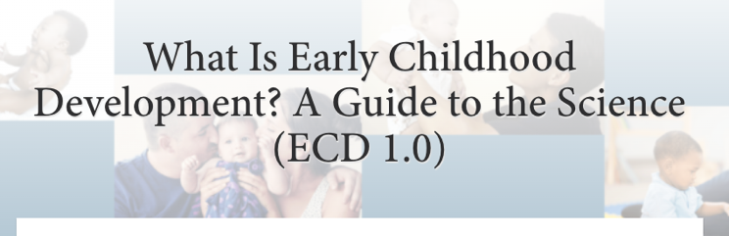
Resource in Focus: Harvard University: Center on the Developing Child: What Is Early Childhood Development? A Guide to the Science

Directions:

Step 1: On your own, visit this resource hub and select one resource on the page to review in depth. (5 minutes)

Step 2: With a partner, share information about the section you chose and what you learned. (5 minutes)

Step 3: As a group, discuss the following questions. Use the space below to jot down notes.* (15 minutes) *Short on time? Focus on Question 4.

- What did you learn that was helpful? Not helpful?

- What do we know about how neuroscience informs our state/district/program’s early literacy efforts?

- Are there other early childhood development resources that you know of? Can you share them with the group? What is the same? What is different?

- What does this information tell us about our own programming?

  - What will we do with this information?

  - What steps do we need to take to move our work forward?

- What questions do we still have? Where should we look for answers?

Step 4: Debrief the process of reviewing a resource as a group. What might improve the process next time? (5 minutes)

