Discussion Activity (30 minutes):
Are there state examples of how to engage families in early childhood literacy?

Resources in Focus: Family Early Literacy Frameworks: Michigan and Maryland
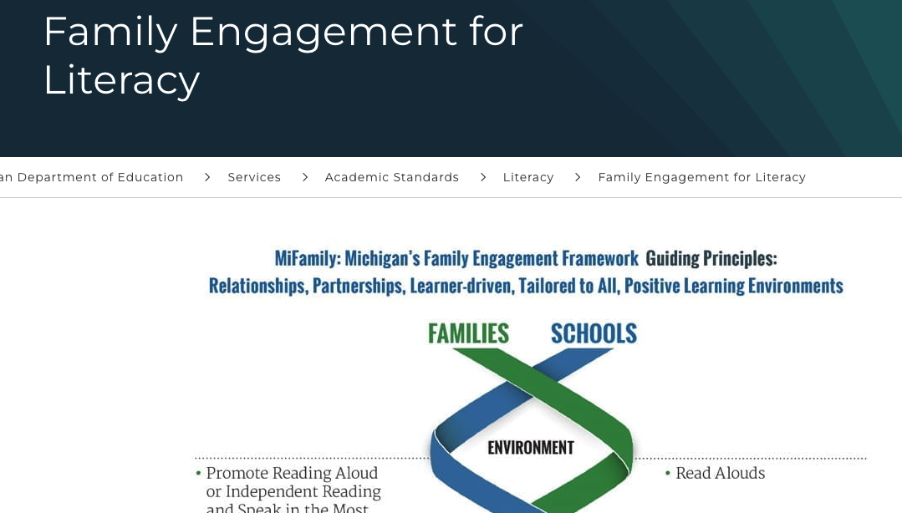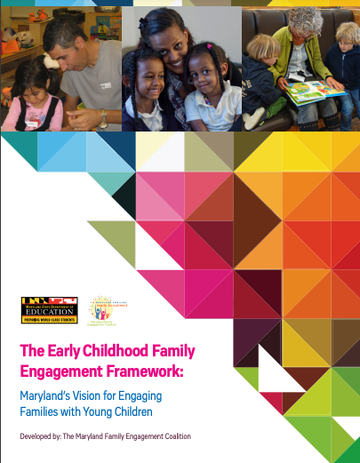

Directions:

Step 1: On your own, choose one of the two state resources listed and skim to review the structure. (5 minutes)

Step 2: With a partner, share information about the section you chose and what you learned. (5 minutes)

Step 3: As a group, discuss the following questions. Use the space below to jot down notes.* (15 minutes) *Short on time? Focus on Question 4.

- What did you learn that was helpful? Not helpful?

- What does our state/district/program currently have to support family literacy?

- Are there family engagement frameworks that you know about? Can you share them with the group? What is the same? What is different?

- What does this information tell us about our own programming?

  - What will we do with this information?

  - What steps do we need to take to move our work forward?

- What questions do we still have? Where should we look for answers?

Step 4: Debrief the process of reviewing a resource as a group. What might improve the process next time? (5 minutes)

